
HOMECHEF – WEB-BASED HOMEMADE FOOD MARKETPLACE
A CAPSTONE PROJECT REPORT

A Capstone Project Report submitted in partial fulfilment of the requirements
for the Course of

CSA4301 - INTERNET PROGRAMMING

to the award of the degree of

BACHELOR OF ENGINEERING / BACHELOR OF TECHNOLOGY
IN
COMPUTER SCIENCE AND ENGINEERING

Submitted by
DHANUSH KUMAR. R -192411215
K. R. JEEVAN BALAJI – 192471032
A. HANUMA SIVA PRABHATH – 192411198
B. S. UDAY KIRAN – 192311185
Under the Supervision of
Dr. MARIE CLAUDE

SIMATS ENGINEERING
Saveetha Institute of Medical and Technical Sciences
Chennai-602105
SEPTEMBER 2026

BONAFIDE CERTIFICATE

This is to certify that the Capstone Project entitled “HOMECHEF – WEB-BASED HOMEMADE FOOD MARKETPLACE” has been carried out by K. R. JEEVAN BALAJI, A. HANUMA SIVA PRABHATH, B. S. UDAY KIRAN, DHANUSH KUMAR under the supervision of Dr. MARIE CLAUDE and is submitted in partial fulfilment of the requirements for the current semester of the B. Tech COMPUTER SCIENCE program at Saveetha Institute of Medical and Technical Sciences, Chennai.

COURSE COORDINATOR
Dr. Anushya. S
Program Director
Department of CSE
SIMATS Engineering
SIMATS, Chennai – 602105.
COURSE FACULTY
Dr. Marie Claude
Professor,
Department of CSE
SIMATS Engineering,
SIMATS, Chennai – 602105.

DECLARATION

We, A. HANUMA SIVA PRABHATH of the Computer Science and Engineering, SIMATS Engineering, Saveetha Institute of Medical and Technical Sciences, Chennai, hereby declare that the Capstone Project Work entitled “HOMECHEF – WEB-BASED HOMEMADE FOOD MARKETPLACE” is the result of our own Bonafide efforts. To the best of our knowledge, the work presented herein is original, accurate, and has been carried out in accordance with the principles of engineering ethics and academic integrity. All sources, references, data, and other materials used in the project have been appropriately acknowledged. We further declare that the data, results, analysis, and findings presented in this report have not been fabricated, falsified, or manipulated. Any external tools, software, datasets, computational resources, or AI-assisted tools used during the project have been appropriately disclosed. We confirm that all applicable ethical, academic, institutional, and professional requirements have been duly followed throughout the planning, execution, analysis, and documentation of the project.

Place: Chennai
Date: 05-09-2026

Signature of the Students with Names

Individual Contribution Statement

Student Name / Register No. | Specific Responsibilities | Design & Development Contribution | Testing & Analysis Contribution | Report Contribution | Approx. Contribution (%)
K. R. JEEVAN BALAJI- | User registration and login | Developed user authentication and profile features | Tested login and registration | Introduction & Problem Analysis | 25%
A. H. SIVA PRABHATH-192411198 | Food listing and search | Developed food categories, search and food display | Tested search and food listing | Solution Design | 25%
B. S. UDAY KIRAN | Cart and order management | Developed cart, ordering and delivery features | Tested orders and delivery status | Results & Testing | 25%
DHANUSH KUMAR. R | Admin and system management | Developed admin features and integrated modules | Tested admin functions and system integration | Conclusion & Final Report | 25%
Total | 100% | 100% | 100% | 100% | 100%

ABSTRACT

The increasing demand for convenient, healthy, and personalized food services has created a need for an organized digital platform that connects customers with home chefs. Many home chefs depend on informal methods such as social media and messaging applications to promote and sell their food, making it difficult to manage food listings, customer orders, payments, and delivery information efficiently. Customers also face difficulties in discovering reliable homemade food options and managing their orders through a single platform.

The development methodology follows a structured software engineering approach involving requirement analysis, system design, user-interface development, backend implementation, database integration, system testing, and evaluation. The application is developed using web technologies for creating a responsive and user-friendly interface, while backend and database components are used to manage users, food information, cart details, and order records.

The project demonstrates the practical application of web development, database management, responsive user-interface design, software testing, and system integration. Overall, HomeChef provides a functional prototype for a digital homemade food marketplace that improves accessibility for customers and provides home chefs with an organized platform to present and manage their food services. The system also provides a foundation for future enhancements such as secure online payments, real-time delivery tracking, ratings and reviews, and personalized food recommendations.

Keywords: Homemade Food Marketplace, Web Application, Online Food Ordering, Home Chefs, Database Management, Responsive Web Design.

TABLE OF CONTENTS

Sl.  No | Title | Page  No
i | CERTIFICATE FROM THE SUPERVISOR | ii
ii | DECLARATION BY THE CANDIDATE | iii
Iii | INDIVIDUAL CONTRIBUTION STATEMENT | iv
iv | ABSTRACT | v
v | LIST OF FIGURES | vi
vi | LIST OF TABLES | vii
vii | LIST OF ABBREVIATIONS | viii
1 | CHAPTER 1: Introduction | 10-12
2 | CHAPTER 2: Literature Review | 13-15
3 | CHAPTER 3: Engineering Design & Trade-offs, Sustainability,  Ethics, Safety, Risk & Security | 16-20
4 | CHAPTER 4: Implementation, Testing & Results, Project  Management | 21-26
5 | CHAPTER 5: Conclusion & Reflection | 27-29
 | References | 30
 | Appendices

LIST OF FIGURES

Figure No. | Figure Name | Page No.
Figure 3.1 | System Architecture of HomeChef | 19
Figure 4.1 | HomeChef Web Portal Interface | 22

LIST OF TABLES
Table No. | Table Name | Page No.
Table 2.1 | Comparative Analysis of Existing Solutions
Table 3.1 | Stakeholder and User Requirements | 16
Table 3.2 | Functional and Non-Functional Requirements | 16
Table 3.3 | Constraints and Applicable Standards | 17
Table 3.4 | Design Specifications | 17
Table 3.5 | Alternative Solutions Evaluation | 18
Table 3.6 | Design Trade-Off Analysis | 19
Table 3.7 | Sustainability, Ethics, Safety and Security Considerations | 20
Table 4.1 | Development Resources Used | 21
Table 4.2 | Software Tools Used for Implementation | 22
Table 4.3 | Test Plan and Verification | 23
Table 4.4 | System Testing Results | 23
Table 4.5 | Achievement of Project Objectives | 25
Table 4.6 | Student Roles and Contributions | 26

LIST OF ABBREVIATIONS / SYMBOLS

Symbol / Abbreviation | Description | Unit
UI | User Interface | –
UX | User Experience | –
HTML | Hypertext Markup Language | –
CSS | Cascading Style Sheets | –
PHP | Hypertext Preprocessor | –
DB | Database | –
JSON | JavaScript Object Notation | –
CRUD | Create, Read, Update and Delete | –
HTTP | Hypertext Transfer Protocol | –
HTTPS | Hypertext Transfer Protocol Secure | –
URL | Uniform Resource Locator | –
API | Application Programming Interface | –
SQL | Structured Query Language | –
MySQL | My Structured Query Language Database System | –
INR | Indian Rupee | ₹
₹ | Indian Currency Symbol | INR
% | Percentage | %
MS | Response Time / Processing Time | Milliseconds
s | Time | Seconds
MB | Data Storage Size | Megabytes

CHAPTER 1
INTRODUCTION AND ENGINEERING PROBLEM

1.1 BACKGROUND
The food industry is increasingly using web-based technologies to connect customers with food providers and make food ordering more convenient. Many people prefer homemade food because of its taste, freshness, affordability, and traditional preparation methods. However, home chefs and small-scale food sellers often face difficulties in reaching customers beyond their local area.
HomeChef – Web-Based Homemade Food Marketplace is designed as an online platform that connects home chefs with customers. The system allows home chefs to list and promote their homemade food items, while customers can browse available foods, search by category, view food details, place orders, and manage their deliveries.
The system also includes features for user management, food listing, search and filtering, cart management, order processing, delivery details, and administrative management. By integrating these functions into a single web-based platform, the project provides a structured digital marketplace for buying and selling homemade food.
1.2 NEED FOR THE PROJECT
The project is needed to address the difficulties faced by home chefs in promoting and selling their food products through an organized online platform.
Why the problem needs to be addressed
- Home chefs have limited access to a wider customer market.
- Customers may find it difficult to discover reliable homemade food providers.
- Manual food ordering through calls or messages can be difficult to manage.
- Order, delivery, and customer information need to be managed systematically.
Who is affected
- Home Chefs: Need a platform to advertise and sell their food.
- Customers: Need an easy way to find and order homemade food.
- Administrators: Need tools to manage users, food listings, and orders.
Existing Limitations
- Limited online visibility for small home-based food sellers.
- Unorganized ordering and communication processes.
- Difficulty in managing multiple food orders.
- Limited systems specifically focused on homemade food marketplaces.
Engineering Significance
The project demonstrates the development of a web-based marketplace by integrating user management, product management, search, ordering, delivery management, and administrative functions into one system.
1.3 PROBLEM STATEMENT
Home chefs and small-scale homemade food providers often face difficulties in reaching customers and managing food orders through an organized digital platform. At the same time, customers require a simple and reliable system for discovering homemade food, viewing food details, placing orders, and tracking their orders.
The engineering problem is to design and develop a web-based homemade food marketplace that manages multiple interacting functions such as user authentication, food listing, search and filtering, cart management, order processing, delivery information, and administration.
The system must provide a user-friendly interface while maintaining accurate food and order information. It must also handle different users and their responsibilities, including customers, home chefs, and administrators, within realistic web application constraints.
1.4 PROJECT AIM
To design and develop a web-based homemade food marketplace that connects home chefs with customers and provides facilities for food browsing, ordering, delivery management, and administrative control.
1.5 PROJECT OBJECTIVES
- To design a user-friendly web-based platform for homemade food services.
- To develop user registration, login, and account management features.
- To implement food listing, category, search, filtering, and food description features.
- To develop cart and order management functionality for customers.
- To implement delivery address and order status management.

1.6 SCOPE
Included
- User registration and login.
- Homemade food listing and management.
- Cart management.
- Food ordering.
- Delivery address management.
- Order and delivery status tracking.
- Administrative management of food items, users, and orders.
Excluded
- Physical preparation of food.
- Actual food delivery operations.
- Large-scale integration with external food delivery services.
Assumptions
- Users have access to an internet-enabled device.
- Home chefs provide correct food and product information.
- Customers provide valid delivery details.
Boundary Conditions
The project is limited to a web-based prototype that demonstrates the major functions of a homemade food marketplace. The system focuses on the interaction between customers, home chefs, and administrators.
1.7 EXPECTED ENGINEERING OUTCOME
The expected outcome of the project is a functional web-based marketplace prototype called Home Chef.
The developed system is expected to provide:
- A digital platform for connecting home chefs and customers.
- Cart and online order management.
- Delivery address and order status management.
- Administrative tools for managing users, food products, and orders.
Overall, the project is expected to demonstrate the practical development of an integrated web-based homemade food marketplace system that provides a simple, organized, and user-friendly solution for promoting and ordering homemade food.
CHAPTER 2
LITERATURE REVIEW AND EXISTING SOLUTIONS

2.1 REVIEW METHOD
The literature and existing solutions related to the HomeChef – Web-Based Homemade Food Marketplace project were identified by reviewing recent research on online food delivery systems, web-based marketplaces, customer adoption of food delivery platforms, and digital food ordering technologies.
Existing commercial platforms were also reviewed to understand commonly used features such as food discovery, search, ordering, payment, delivery tracking, and seller management. Platforms such as, and were considered for comparison.
The review focused on the following areas:
- Online food ordering and delivery systems.
- Home-based and local food providers.
- Web technologies used for marketplace development.
Recent research shows that convenience, trust, perceived value, and ease of use are important factors influencing the adoption of online food delivery services.

2.2 REVIEW OF EXISTING WORK
A. Research on Online Food Delivery Systems
Research on online food delivery systems has examined the factors that influence customer adoption and continued use of digital food platforms. Studies show that factors such as convenience, performance, trust, perceived risk, and ease of use play an important role in customer decision-making.
A systematic literature review of online food delivery research identified important areas including digital interaction between stakeholders, operational management, consumer adoption, and trust and risk issues.
B. Existing Commercial Food Delivery Platforms
Provides features such as restaurant discovery, menu browsing, food ordering, payment, and delivery tracking. It also supports technology-enabled services for partner businesses and local brands.
Represents another approach by connecting users with local hosts and food experiences, allowing users to discover and book dining experiences offered by individuals. This demonstrates the potential of digital platforms for connecting customers with independent food providers.

C. TECHNOLOGIES AND METHODS USED
Existing food ordering systems commonly use web and mobile technologies to provide:
- User registration and authentication.
- Online ordering.
- Delivery and order tracking.
- Administrative management.
The HomeChef project applies similar marketplace concepts but focuses specifically on connecting customers with home chefs and homemade food providers.

2.3 COMPARATIVE ANALYSIS

Existing Approach | Advantages | Limitations | Relevance to Proposed Work
Traditional Food Ordering | Simple and familiar communication | Manual order management and limited customer reach | Shows the need for digital ordering
Large Food Delivery Platforms | Search, ordering, payment, and delivery features | Mainly focused on restaurants and large delivery networks | Provides ideas for ordering and delivery management
Restaurant-Specific Websites | Direct connection between restaurant and customer | Limited food choices and providers | Demonstrates web-based ordering features
Local Food Experience Platforms | Connects customers with local food providers | Often focused on experiences rather than regular food orders | Relevant to connecting customers with independent home chefs

Table 2.1 - Comparative Analysis of Existing Solutions
The comparison shows that existing systems provide useful food discovery and ordering features, but they are generally designed for restaurants, commercial food providers, or dining experiences.
2.4 RESEARCH / ENGINEERING GAP
The review of existing solutions identifies a gap between large commercial food delivery platforms and small home-based food providers.
Identified Gaps
- Large platforms mainly focus on restaurants and established food businesses.
- Home chefs may have limited access to dedicated digital marketplaces.
- Small-scale homemade food providers require a simple and accessible system.
2.5 PROPOSED CONTRIBUTION
The proposed HomeChef – Web-Based Homemade Food Marketplace aims to address the identified gap by developing a platform specifically focused on homemade food providers and customers.
The major contributions of the proposed system include:
- Providing a dedicated platform for home chefs to display and promote homemade food.
- Allowing customers to browse food items by category.
- Providing search and filtering for easier food discovery.
- Displaying food details such as descriptions, prices, and available items.

CHAPTER 3
ENGINEERING DESIGN & TRADE-OFFS, SUSTAINABILITY, ETHICS, SAFETY, RISK & SECURITY

3.1 REQUIREMENTS
Stakeholder | Requirement
Customers | Browse, search, and order homemade food easily.
Home Chefs | List and manage homemade food products.
Administrators | Manage users, food listings, and orders.
Customers | Add food items to cart and place orders.

Table 3.1 - Stakeholder and User Requirements

Functional & Non-Functional Requirements

Requirement | Type | Measurable Target
User registration and login | Functional | Users can create and access accounts successfully
Food listing and management | Functional | Food items can be added, viewed, and updated
Admin management | Functional | Admin can manage food, users, and orders

Table 3.2 - Functional and Non-Functional Requirements

3.2 CONSTRAINTS & APPLICABLE STANDARDS
The project is developed as a web-based prototype and is subject to practical technical and security constraints.
Project Constraints
- The system depends on internet connectivity.
- The project is developed as a web-based prototype.
- Real-world delivery infrastructure is outside the project scope.

Standard / Code | Requirement | How Applied in This Project
OWASP Top 10 | Protect web applications against common security risks | Input validation, authentication, and protected user access are considered
WCAG 2.1 | Improve accessibility and usability of web content | Clear text, readable layouts, and simple navigation are used
HTTPS / TLS Principles | Secure communication between users and the web system | Secure communication should be used when deployed online
Software Engineering Principles | Maintain modular and maintainable software | The system is divided into user, food, order, and admin modules
Data Privacy Principles | Protect user information | Only required user and order information is collected and managed

Table 3.3 - Constraints and Applicable Standards

3.3 DESIGN SPECIFICATIONS
Parameter | Target / Requirement | Unit | Priority
User Authentication | Secure user login and registration | Successful access | High
Food Search | Search and filter food items | Response | High
Food Management | Add, update, and display food items | Records | High
Order Processing | Create and manage customer orders | Orders | High
Data Security | Protect user information | Secure access | High
Admin Management | Manage users and orders | System functions | High
System Availability | Access through web browser | Online access | Medium

Table 3.4 - Design Specifications

3.4 Alternative Solutions & Evaluation
Alternative 1: Social Media-Based Food Selling
Home chefs can advertise food through social media platforms and receive orders through messages or calls. This approach is simple and low-cost but does not provide structured order, cart, or customer management.
Alternative 2: Mobile Application
A dedicated mobile application can provide food browsing and ordering features. However, mobile application development requires additional development effort and maintenance for different devices.
Alternative 3: Web-Based Marketplace
A web-based marketplace provides centralized food browsing, ordering, and administration through a web browser. It is easier to access without requiring users to install a separate application.
Evaluation Matrix
Scores: 1 = Low, 5 = High
Criterion | Weight | Alternative 1 social media | Alternative 2 Mobile App | Alternative 3 Web Marketplace
Performance | 0.25 | 2 | 4 | 4
Cost | 0.20 | 5 | 2 | 4
Sustainability | 0.15 | 3 | 3 | 4
Reliability | 0.20 | 2 | 4 | 4
Weighted Result | 1.00 | 2.75 | 3.50 | 4.00

Table 3.5 - Alternative Solutions Evaluation

3.5 Selected Design & Detailed Design
The Web-Based Marketplace was selected because it received the highest score in the evaluation matrix. It provides structured food management and ordering features while remaining accessible through a standard web browser without requiring a separate mobile application.
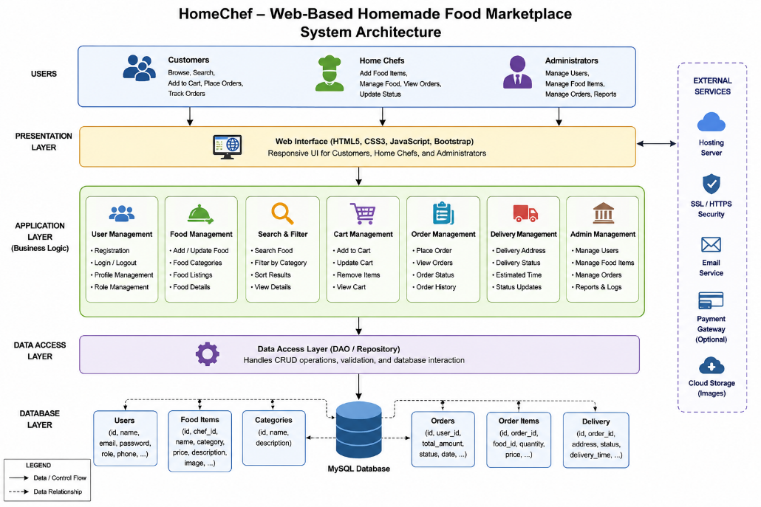
Figure 3.1 - System Architecture of HomeChef

Systems Approach
The system consists of multiple connected modules. The user management module controls access to the system. The food listing module provides food information to customers, while the cart and order modules process customer selections and orders.
The admin module manages users, food items, and orders. All modules communicate with the database to store and retrieve the required information.

3.6 TRADE-OFF ANALYSIS
Design Decision | Alternative Considered | Benefit | Disadvantage | Final Decision & Justification
Web application | Mobile application | Easy access through browser | May have fewer device-specific features | Selected because no installation is required
Centralized marketplace | Social media selling | Structured food and order management | Requires system development | Selected for better organization
Database storage | Manual record management | Reliable and structured data storage | Requires database configuration | Selected for efficient data management
Table 3.6 - Design Trade-Off Analysis
3.7 SUSTAINABILITY, ETHICS, SAFETY, RISK & SECURITY

Domain | Consideration | Evidence Evaluated | Impact on Final Decision
Sustainability | Supporting local home chefs and reducing dependence on physical advertising | Digital food listings reduce the need for printed advertisements and allow local food providers to reach customers online | A web-based digital marketplace was selected
Ethics | Fair representation of food information and user privacy | Incorrect food descriptions or misuse of customer information can reduce trust | Food details and user information should be managed responsibly
Health & Safety | Food quality, hygiene, and allergen information | Homemade food may involve differences in ingredients and preparation methods | The platform should allow clear food descriptions and relevant food information

Table 3.7 – Sustainability, Ethics, Safety and Security Considerations
CHAPTER 4
IMPLEMENTATION, TESTING & RESULTS, PROJECT MANAGEMENT

4.1 Development Approach & Resources
The HomeChef – Web-Based Homemade Food Marketplace was developed using a modular web development approach. The system was divided into major modules such as user management, food management, search and filtering, cart management, order management, delivery management, and admin management. Each module was developed and tested individually before being integrated with the database. Finally, the complete system was tested to verify that users, home chefs, and administrators could perform their required operations.
Resources Used
Resource | Purpose
Food and user data | Testing system functionality
Sample food images | Displaying food listings
MySQL Database | Storing users, food items, and orders
Web browser | Testing the application
Development computer | Developing and running the system

Table 4.1 – Development Resources Used

4.2 Hardware / Software Implementation & Modern Tools Used
Software Implementation
The HomeChef system was implemented as a web-based application. The frontend provides separate interfaces for customers, home chefs, and administrators. The application modules process user actions such as registration, food browsing, searching, cart operations, order placement, and order management. A database is used to store and manage user, food, category, order, and delivery information.

Tools Used
Tool / Software / Equipment | Purpose | Stage Used
HTML5 | Creating webpage structure | Frontend Development
CSS3 | Designing and styling the interface | Frontend Development
JavaScript | Adding interactive functionality | Frontend Development
Bootstrap | Creating responsive user interfaces | UI Development
PHP | Server-side application processing | Backend Development
MySQL | Database storage and management | Database Development
XAMPP / PHP Server | Running the web application locally | Testing

Table 4.2 - Software Tools Used for Implementation

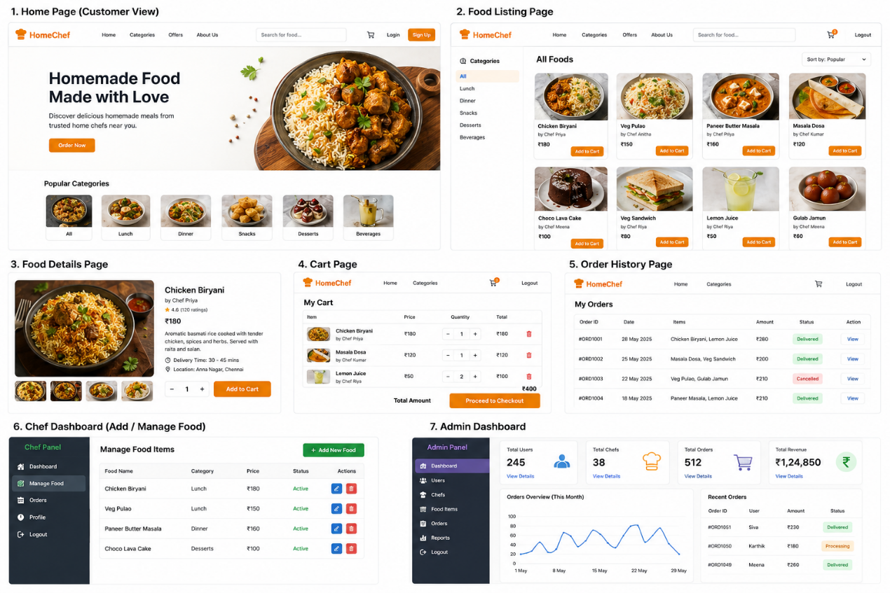
Figure 4.1 - HomeChef Web Portal Interface
4.3 TEST PLAN & VERIFICATION

Requirement | Test Method | Acceptance Criterion
User Registration | Create a new user account | User account should be created successfully
User Login | Enter valid login credentials | User should access the dashboard
Food Search | Search for a food item | Matching food items should be displayed
Place Order | Submit order details | Order should be created successfully
View Orders | Open order history | User orders should be displayed
Food Management | Add or update food details | Changes should be saved successfully

Table 4.3 - Test Plan and Verification

Verification Results

Specification | Required Value | Achieved Value | Status
User Registration | Successful account creation | Successful | Pass
User Login | Valid user access | Successful | Pass
Food Search | Display relevant results | Successful | Pass
Food Filtering | Filter by category | Successful | Pass
Cart Management | Add and update items | Successful | Pass
Order Placement | Create an order | Successful | Pass
Order History | Display previous orders | Successful | Pass
Food Management | Add and update food items | Successful | Pass
Admin Management | Manage system data | Successful | Pass
Responsive Interface | Support common screen sizes | Successful | Pass

Table 4.4 - System Testing Results

4.4 RESULTS
The implementation of the HomeChef system successfully produced a functional web-based marketplace for homemade food. Customers can register, log in, browse food items, search and filter products, add items to the cart, and place orders.
Home chefs can manage their food listings and update food-related information. Administrators can manage users, food items, orders, and system information. The database successfully stores and retrieves the required information for the different modules.
Key Results
- Successful user registration and login.
- Successful display of homemade food listings.
- Food search and category filtering implemented.
- Cart management functions working correctly.
- Order placement and order history supported.
- Food management functionality available for home chefs.
- Administrative management functions implemented.
- Database successfully stores system information.
- Responsive web interface developed.

4.5 DATA ANALYSIS & ENGINEERING JUDGMENT
The testing results show that the major functional requirements of the HomeChef system were successfully implemented. The modular design helped separate different system operations, making the application easier to test and manage.
The use of a centralized database improved the consistency of user, food, and order information. Search and filtering functions improved the ability of customers to locate required food items, while cart and order management provided a structured ordering process.
The project is designed as a prototype, and therefore some advanced real-world features may require further development. Features such as real-time delivery tracking, advanced payment integration, and automatic food verification can be improved in future versions.

4.6 COMPARISON WITH EXISTING SOLUTIONS & ACHIEVEMENT OF OBJECTIVES

Objective | Evidence | Achievement
To design a web-based food marketplace | System architecture and user interface developed | Fully Achieved
To develop user registration and login | User authentication module implemented | Fully Achieved
To implement food listing and management | Food items can be added, viewed, and managed | Fully Achieved
To implement search and filtering | Search and category filtering functions available | Fully Achieved
To implement cart and order management | Users can add items and place orders | Fully Achieved
To develop an admin management module | Admin can manage users, food, and orders | Fully Achieved
To test the developed system | Major modules were tested successfully | Fully Achieved
To provide real-time delivery tracking | Basic delivery management supported | Partially Achieved
Table 4.5 - Achievement of Project Objectives

4.7 STRENGTHS & LIMITATIONS
Strengths
- Provides a centralized platform for homemade food selling.
- Supports customers, home chefs, and administrators.
- Simple and user-friendly interface.
- Food search and filtering improve usability.
- Structured cart and order management.
- Database-based storage improves data management.
- Modular architecture improves maintainability.
- Responsive web design supports different devices.
Limitations
- The system depends on internet connectivity.
- Real-time delivery tracking may require additional integration.
- Advanced online payment features may require third-party services.
- Food quality verification is outside direct system control.
- Large-scale deployment may require improved server infrastructure.
- Advanced recommendation and personalization features are not included in the current prototype.

Student Roles & Contributions

Student | Assigned Responsibility | Actual Contribution
Student 1 | System analysis, requirement gathering, project planning, and documentation | 25%
Student 2 | UI/UX design, frontend development, and responsive interface implementation | 25%
Student 3 | Backend development, database design, user authentication, and order management | 25%
Student 4 | System integration, testing, debugging, result analysis, and report preparation | 25%
Total | Overall project development and documentation | 100%

Table 4.6 - Student Roles and Contributions

CHAPTER 5
CONCLUSION, FUTURE WORK AND REFLECTION

5.1 CONCLUSION
The HomeChef – Web-Based Homemade Food Marketplace project was developed to address the need for an organized digital platform connecting customers with home chefs. Traditional methods of selling homemade food through social media and messaging applications can make food discovery, order management, and customer interaction difficult.
The proposed solution provides a web-based marketplace where users can register, browse homemade food items, search and filter food, add items to a cart, and place orders. The system also provides administrative functionality for managing food items, users, and orders.
The developed system was implemented and tested to verify its major functional requirements. The results showed successful operation of the main modules, including food browsing, cart management, order processing, and administrative management.
Overall, the project achieved its aim of developing a functional and user-friendly web-based homemade food marketplace. The project demonstrates the practical application of web development, database management, responsive interface design, software testing, and system integration. HomeChef provides a useful foundation for connecting home chefs with customers through a centralized digital platform.
5.2 FUTURE WORK
The following enhancements can be considered for future development:
- Integration of secure online payment facilities.
- Real-time delivery and order tracking.
- Development of a mobile application.
- Customer ratings and reviews for food and home chefs.
- Map integration for location and delivery management.
- Personalized food recommendations.
- Advanced sales and order analytics.
- Improved security and user authentication features.

5.3 PROFESSIONAL LEARNING & INDIVIDUAL REFLECTION
New Knowledge Acquired
- Understanding of web-based marketplace development.
- Knowledge of frontend and responsive web design.
- Understanding of backend and database integration.
- Knowledge of user authentication and data management.
- Understanding of cart and order management systems.
- Knowledge of software testing and debugging.
- Understanding of system integration and deployment concepts.
Engineering & Professional Skills Developed
- Web application development skills.
- Database design and management skills.
- Problem-solving and analytical thinking.
- Software testing and debugging skills.
- Teamwork and task coordination.
- Technical documentation skills.
- Communication and project presentation skills.
- Project planning and time-management skills.

INDIVIDUAL REFLECTION
Student 1
The most difficult engineering task was analyzing the system requirements and dividing the project into suitable modules. This was solved by separating the system into user, food, cart, order, and administration modules. A key engineering decision was to follow a modular design because it made development easier to organize.
Student 2
The major challenge was designing a clear and responsive user interface for the web portal. This was solved by organizing the pages with simple navigation and properly structured food information. A key decision was to keep the interface simple to improve usability for customers. New knowledge was gained in responsive frontend development and interface design.

Student 3
The most difficult task was managing application data and connecting the system with the database. This was solved by organizing user, food, and order information in a structured manner. A key engineering decision was to maintain separate data management components for better organization. New knowledge was gained in backend development and database operations.
Student 4
The major challenge was integrating different modules and testing the complete application. This was solved by testing individual functions and then checking their interaction with other modules. A key decision was to perform functional testing before final system integration. New knowledge was gained in debugging, testing, and system evaluation. If repeated, automated testing and additional user feedback would be included.

REFERENCES

[1] Mozilla Developer Network, “Web technology for developers,” MDN Web Docs. [Online]. Available: MDN Web Docs. Accessed: Sep. 2, 2026.
[2] Mozilla Developer Network, “Web developer guides,” MDN Web Docs. [Online]. Available: MDN Web Developer Guides. Accessed: Sep. 2, 2026.
[3] PHP Documentation Group, “PHP Documentation.” [Online]. Available: PHP Documentation. Accessed: Sep. 2, 2026.
[4] Oracle Corporation, “MySQL Documentation,” MySQL. [Online]. Available: MySQL Documentation. Accessed: Sep. 2, 2026.
[5] Microsoft Corporation, “Visual Studio Code Documentation.” [Online]. Available: Visual Studio Code Documentation. Accessed: Sep. 2, 2026.
[6] GitHub, Inc., “GitHub Documentation.” [Online]. Available: GitHub Documentation. Accessed: Sep. 2, 2026.

